|  |
| --- |
|  |
| The Documentation |
| [Type the document subtitle] |
|  |
| **[Your Name]** |
| **[Pick the date]** |

[Type the abstract of the document here. The abstract is typically a short summary of the contents of the document. Type the abstract of the document here. The abstract is typically a short summary of the contents of the document.]

Table of Contents

[To update the table of contents, right click the message below and select Update Field (F9 on PC, ⌥⌘U on Mac).]

**No table of contents entries found.**

1. Pages
   1. Page Tree

Home  
 Liste des exposants  
 Carte des exposants  
 Intervenants à la table ronde  
 Presse et actualité  
 Commande  
 confirmation  
 Connaissance sur le vin et le domaine  
Home Portable  
 Liste des exposants  
 Carte des exposants  
 Intervenant à la table ronde  
 Presse et actualité  
 Commande  
 Confirmation  
 Connaissance sur le vin et le domaine

* 1. Home
     1. User Interface

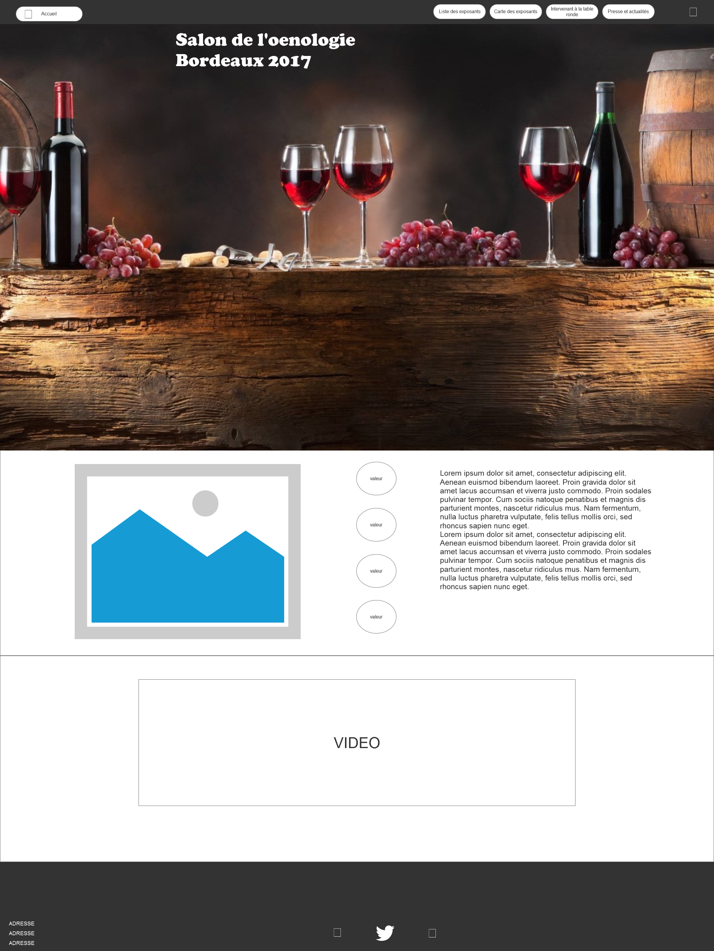

* 1. Liste des exposants
     1. User Interface

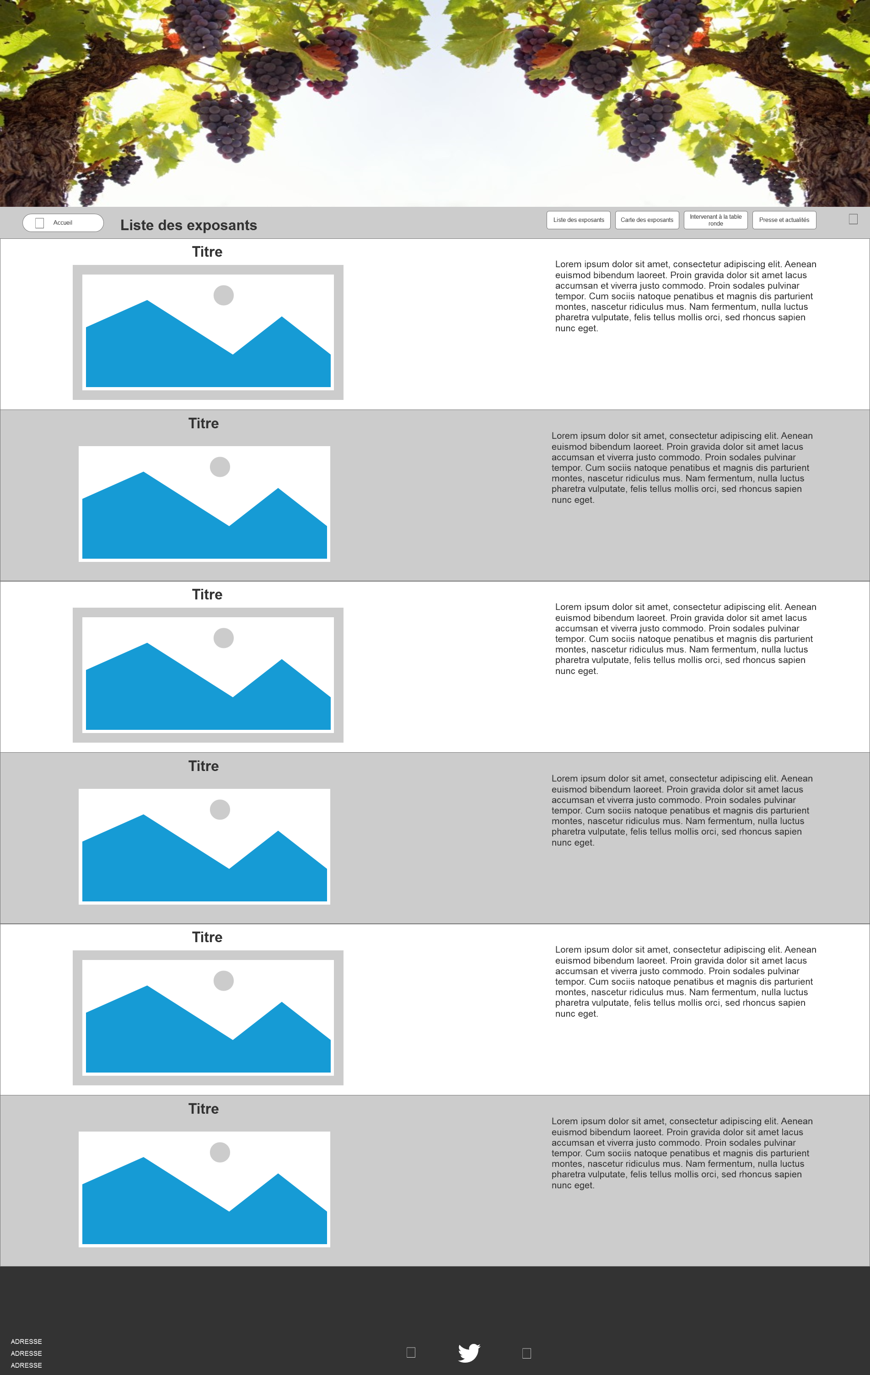

* 1. Carte des exposants
     1. User Interface

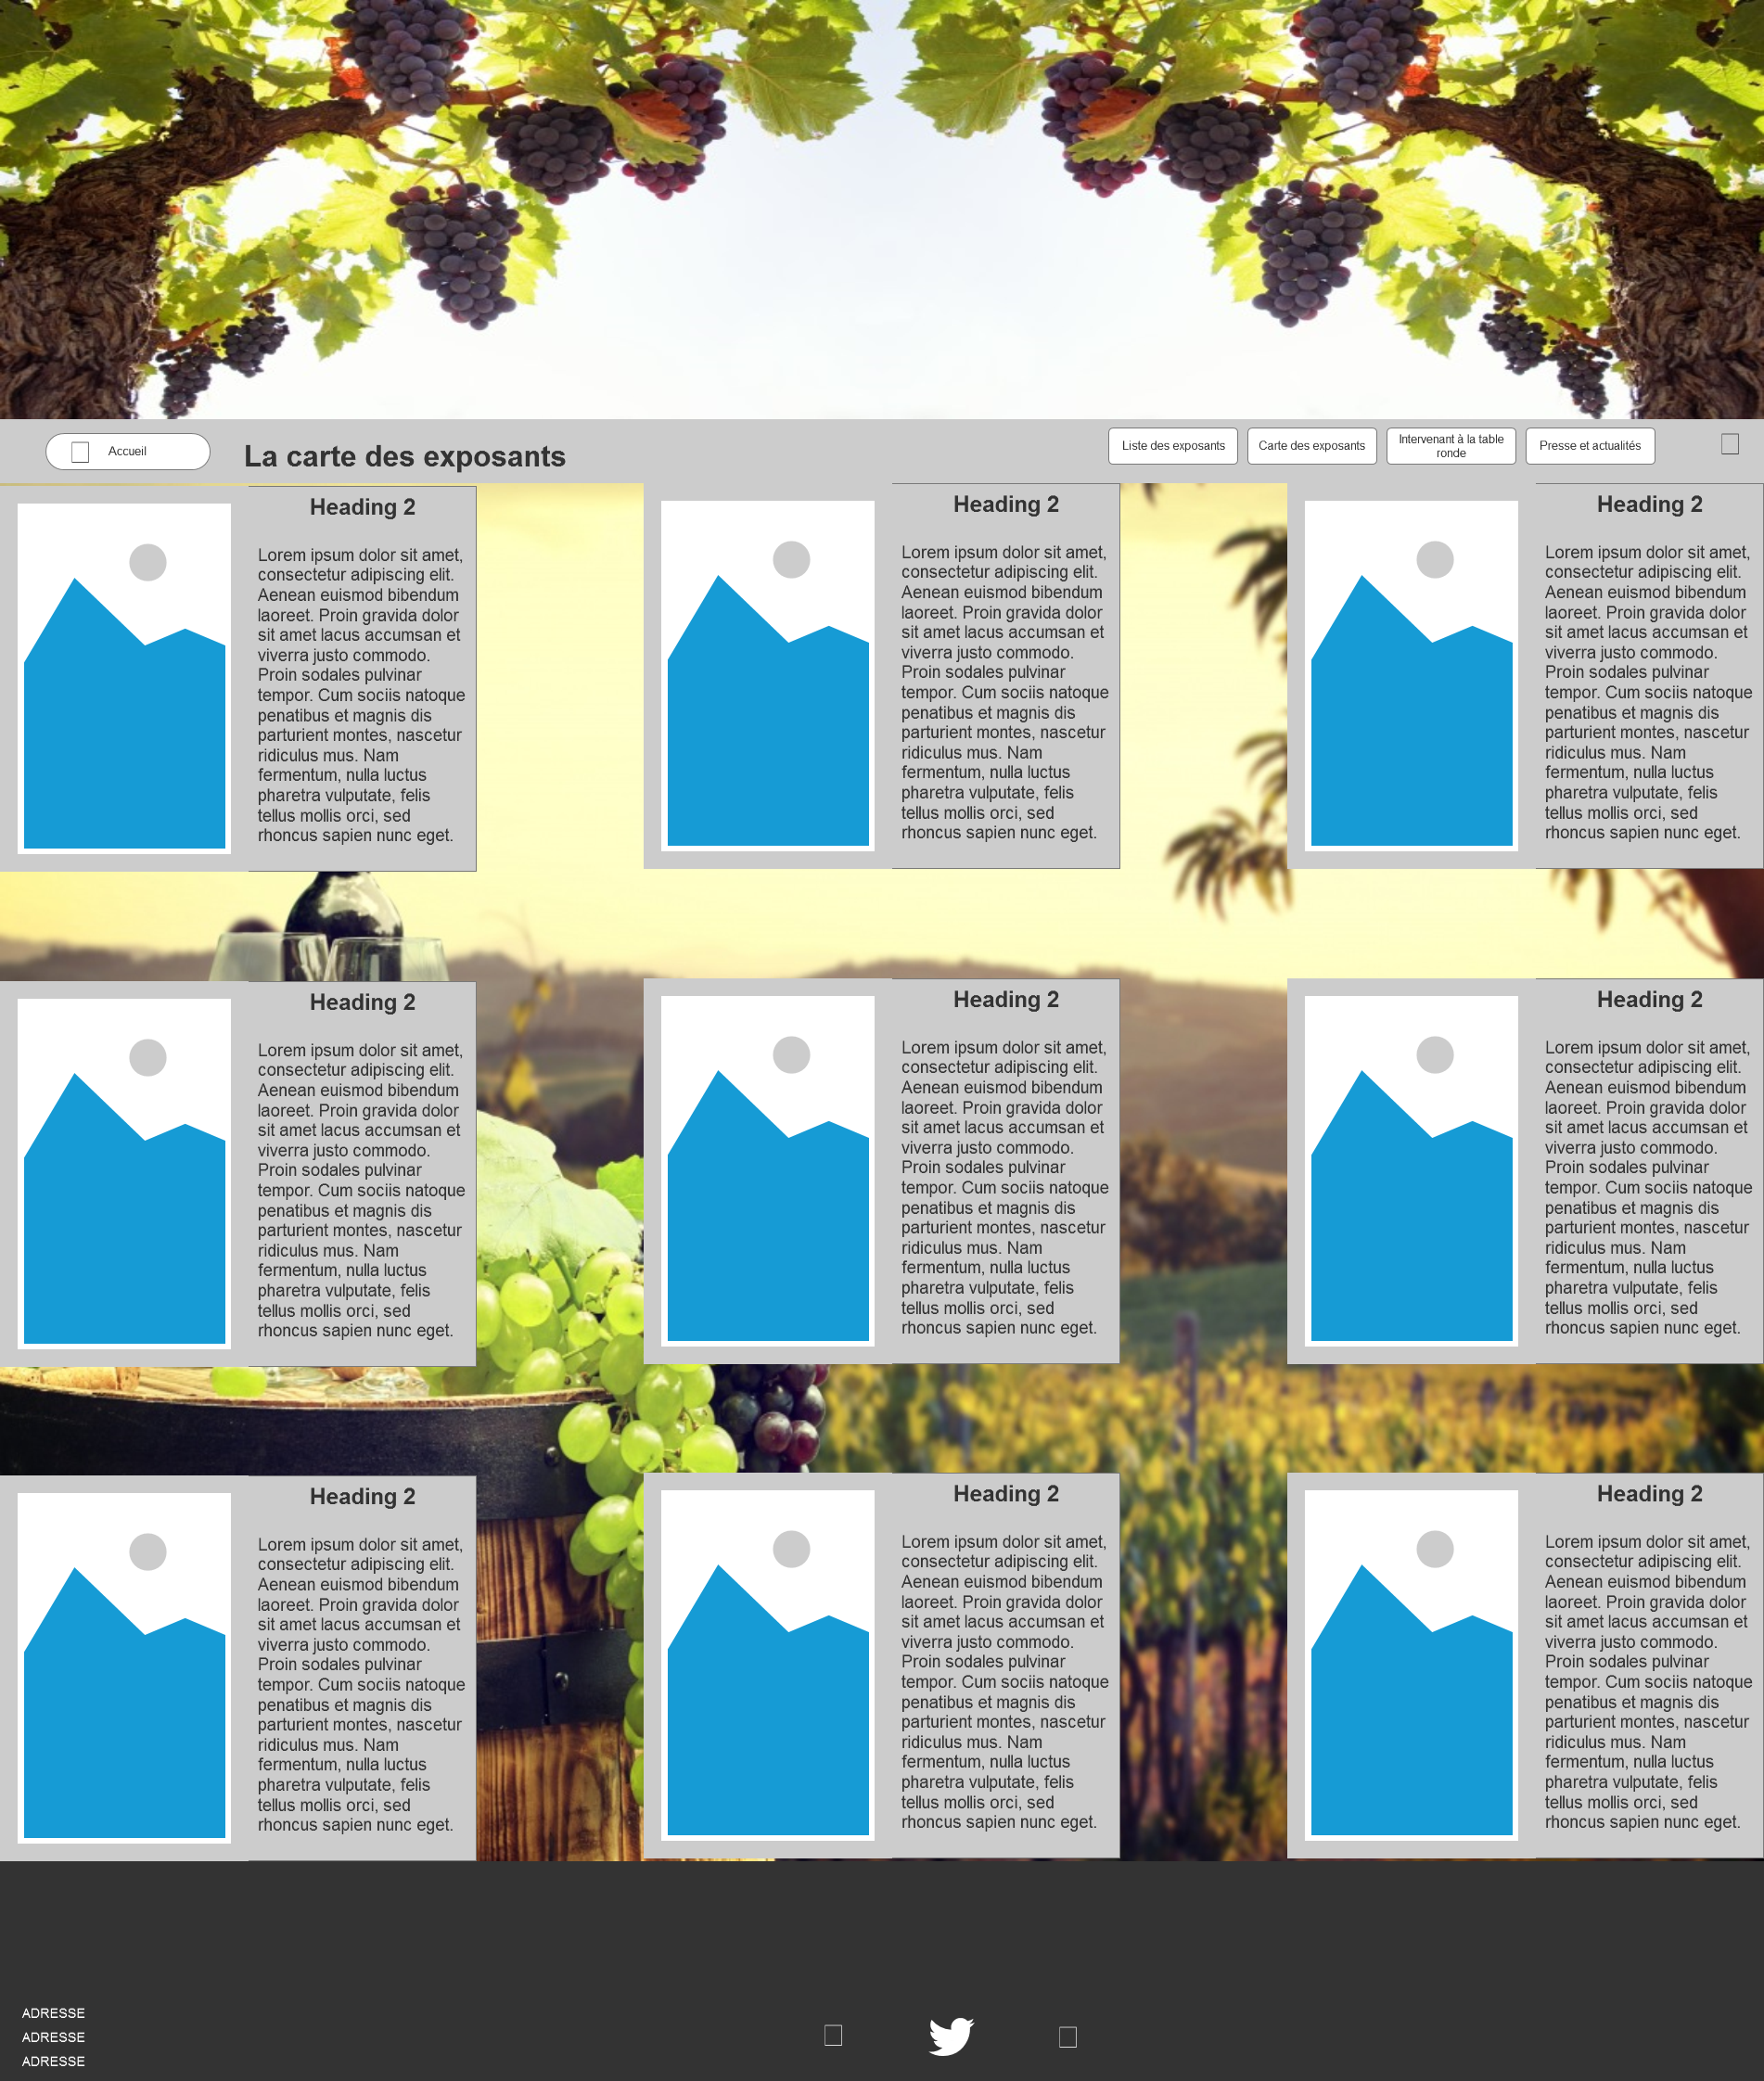

* 1. Intervenants à la table ronde
     1. User Interface

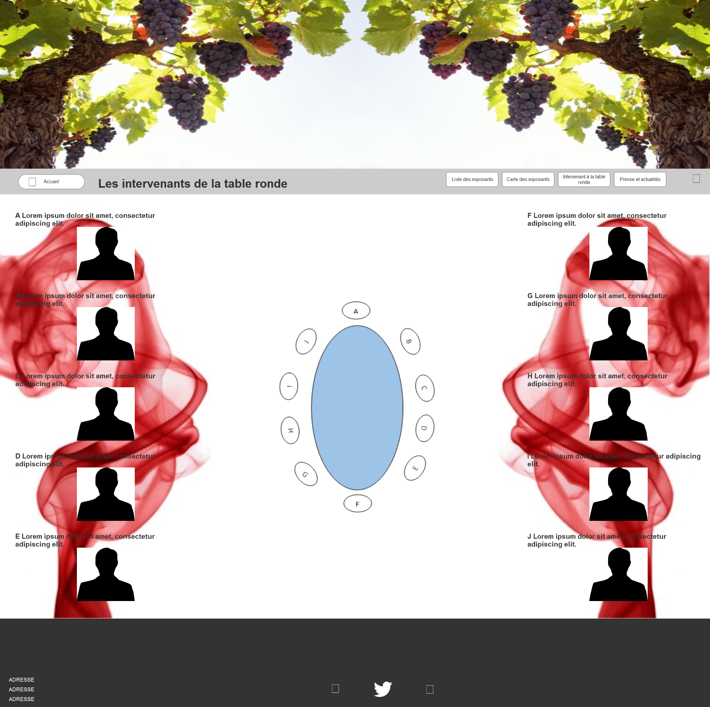

* 1. Presse et actualité
     1. User Interface

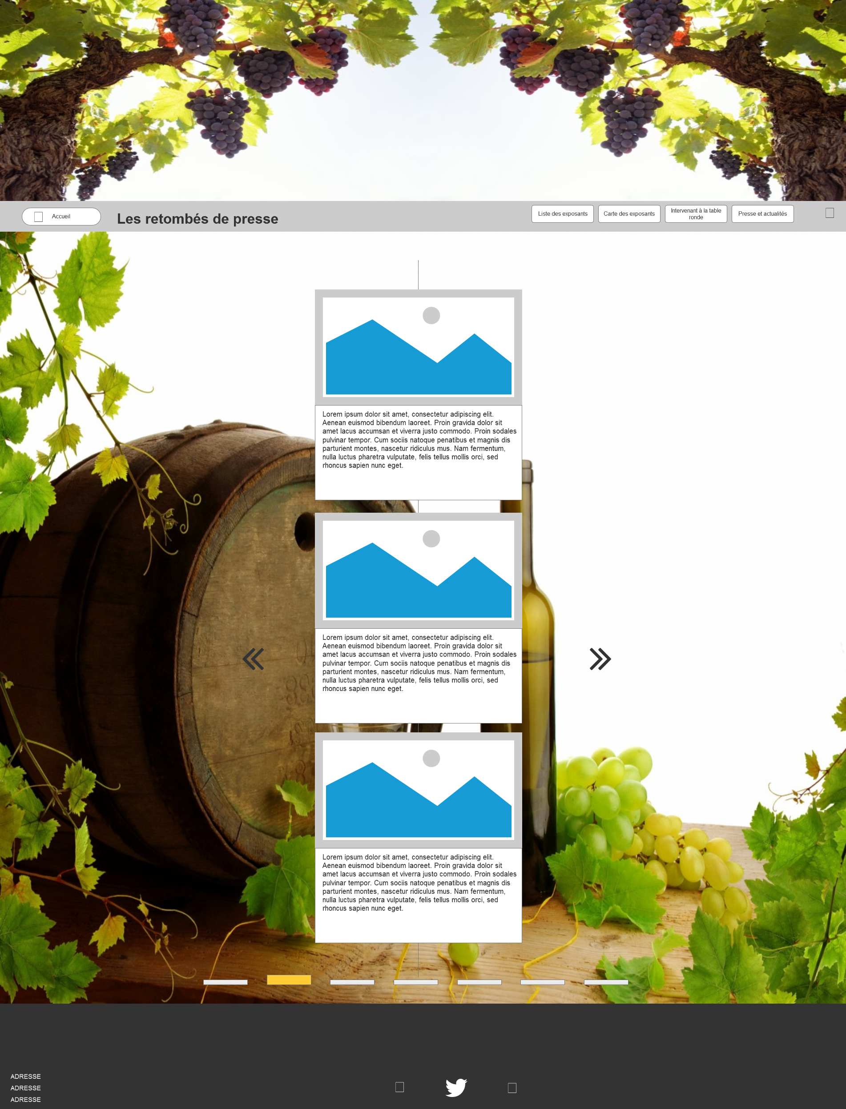

* 1. Commande
     1. User Interface

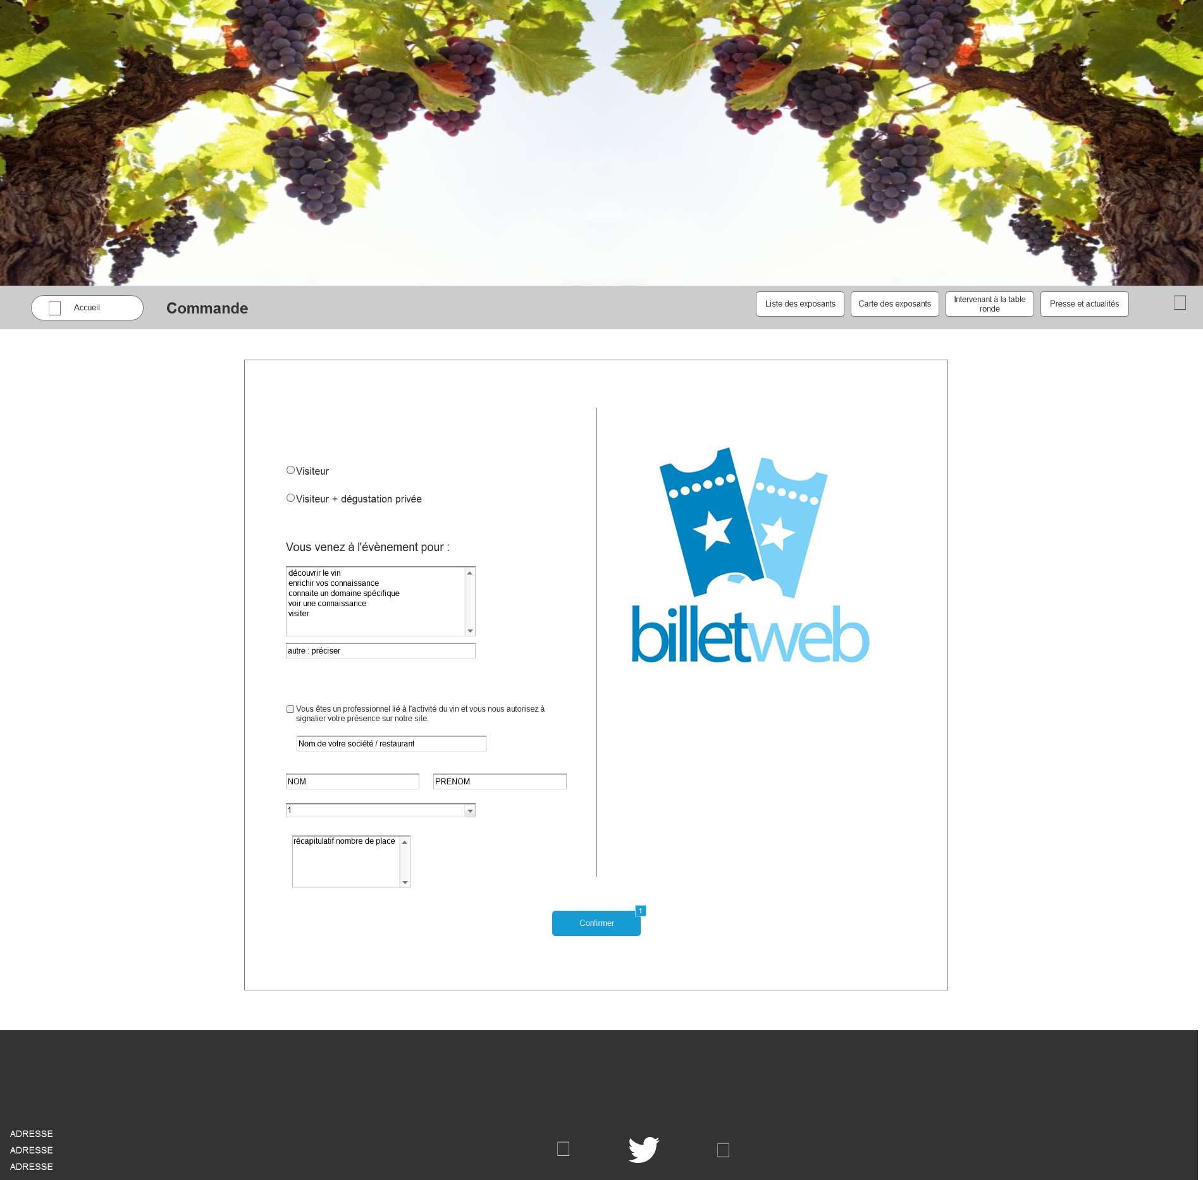

* + 1. Widget Table

| Footnote | Name | Interactions |
| --- | --- | --- |
| 1 |  | OnClick:  Case 1:  Open confirmation in Current Window |

* 1. confirmation
     1. User Interface

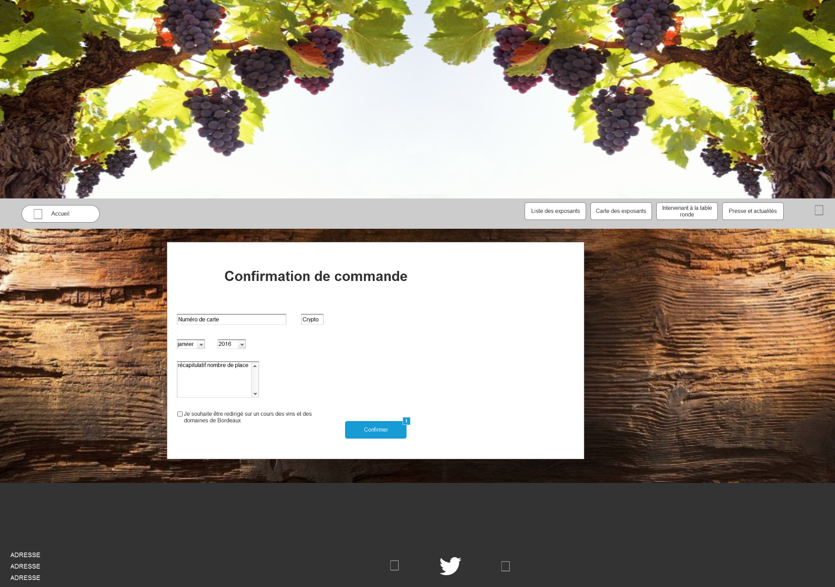

* + 1. Widget Table

| Footnote | Name | Interactions |
| --- | --- | --- |
| 1 |  | OnClick:  Case 1  (If is selected of checkbox cours equals true):  Open Connaissance sur le vin et le domaine in Current Window  Case 2  (Else If is selected of checkbox cours equals false):  Open Home in Current Window |

* 1. Connaissance sur le vin et le domaine
     1. User Interface

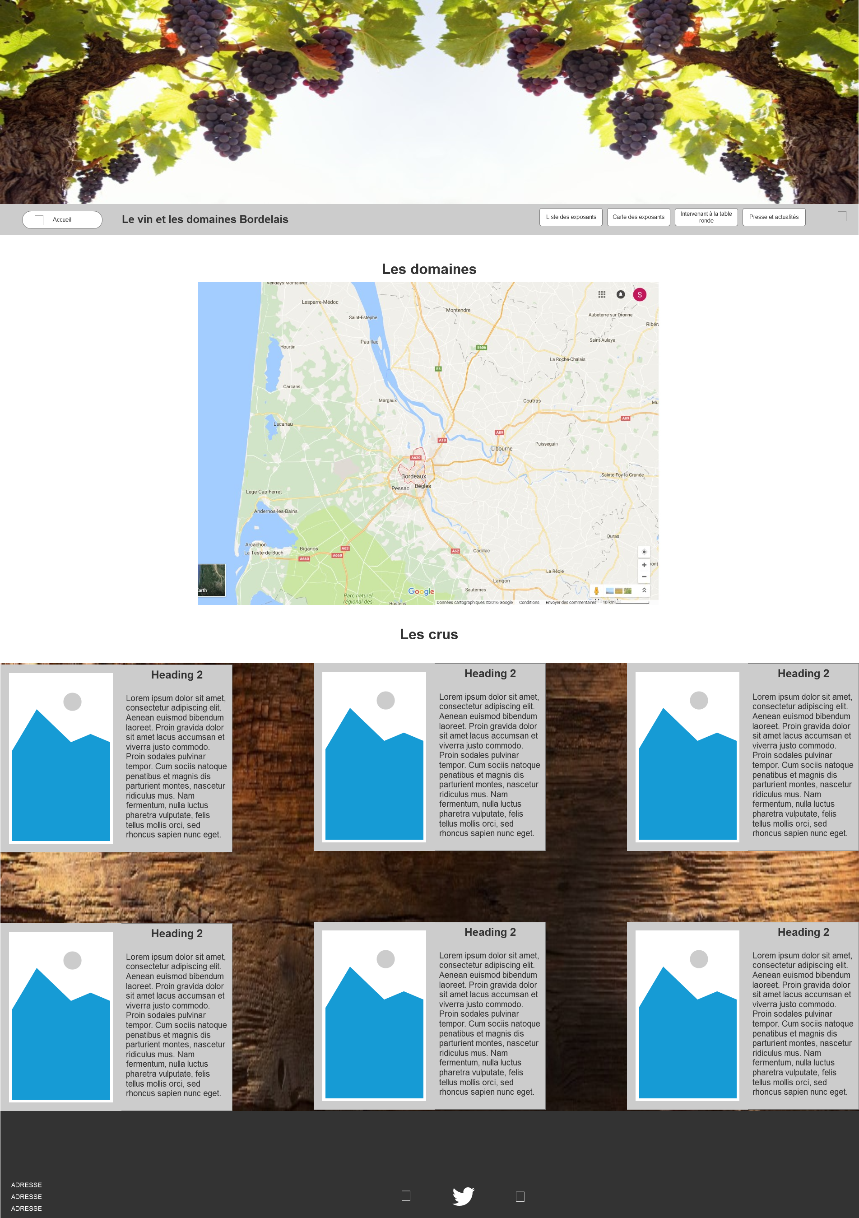

* 1. Home Portable
     1. User Interface

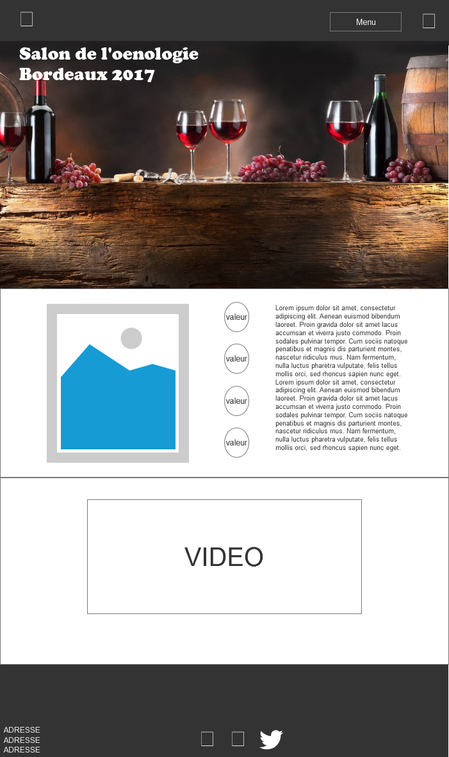

* 1. Liste des exposants
     1. User Interface

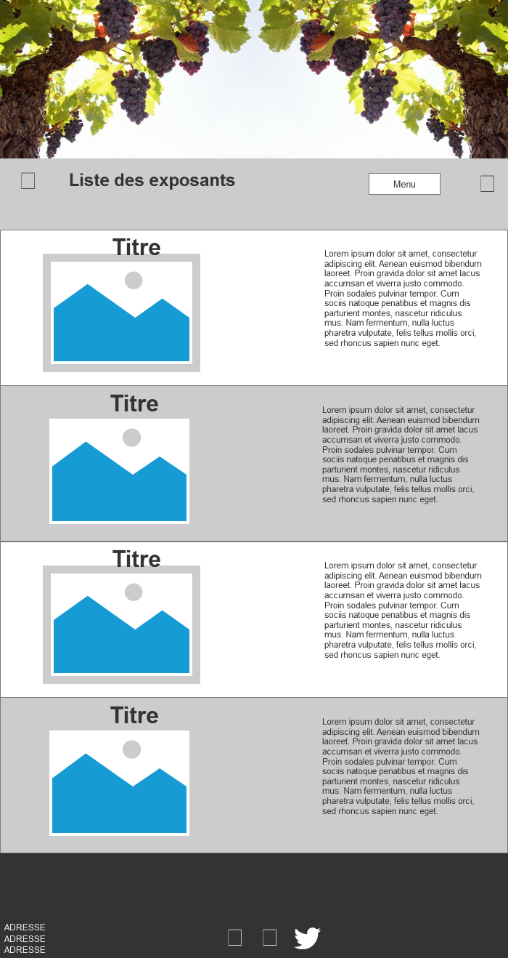

* 1. Carte des exposants
     1. User Interface

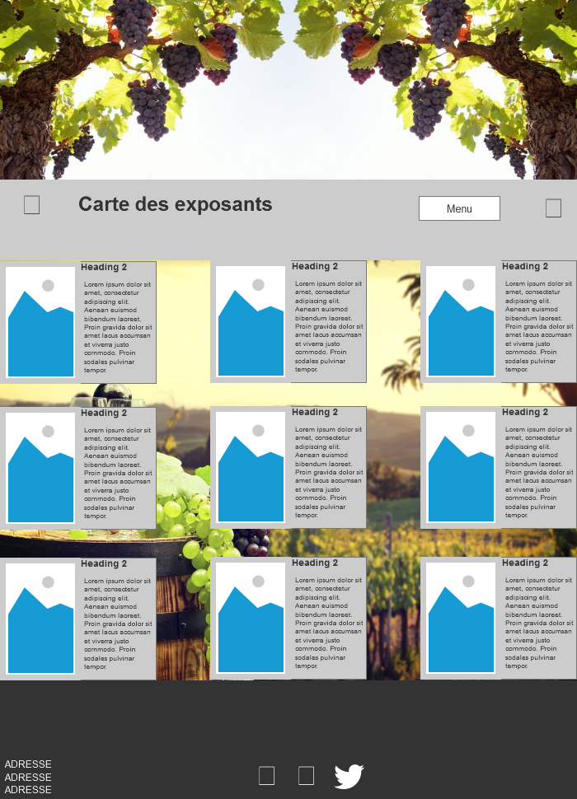

* 1. Intervenant à la table ronde
     1. User Interface

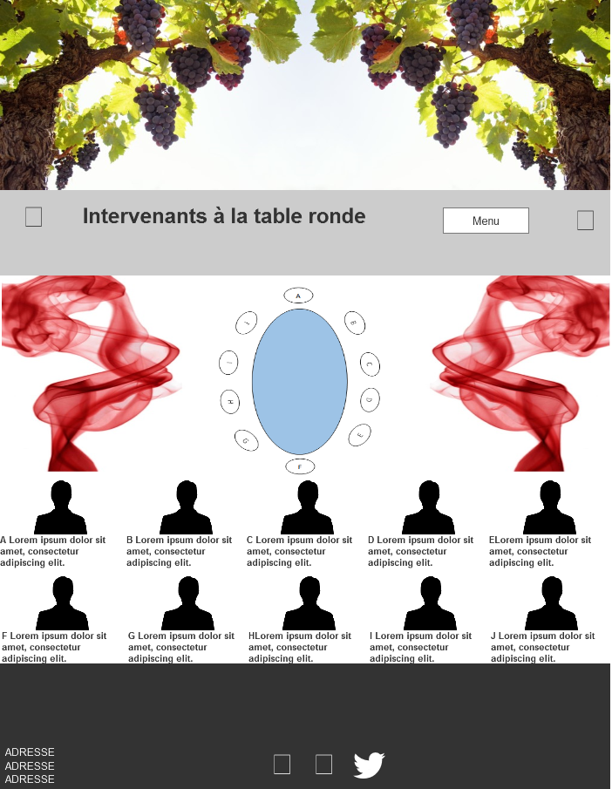

* 1. Presse et actualité
     1. User Interface

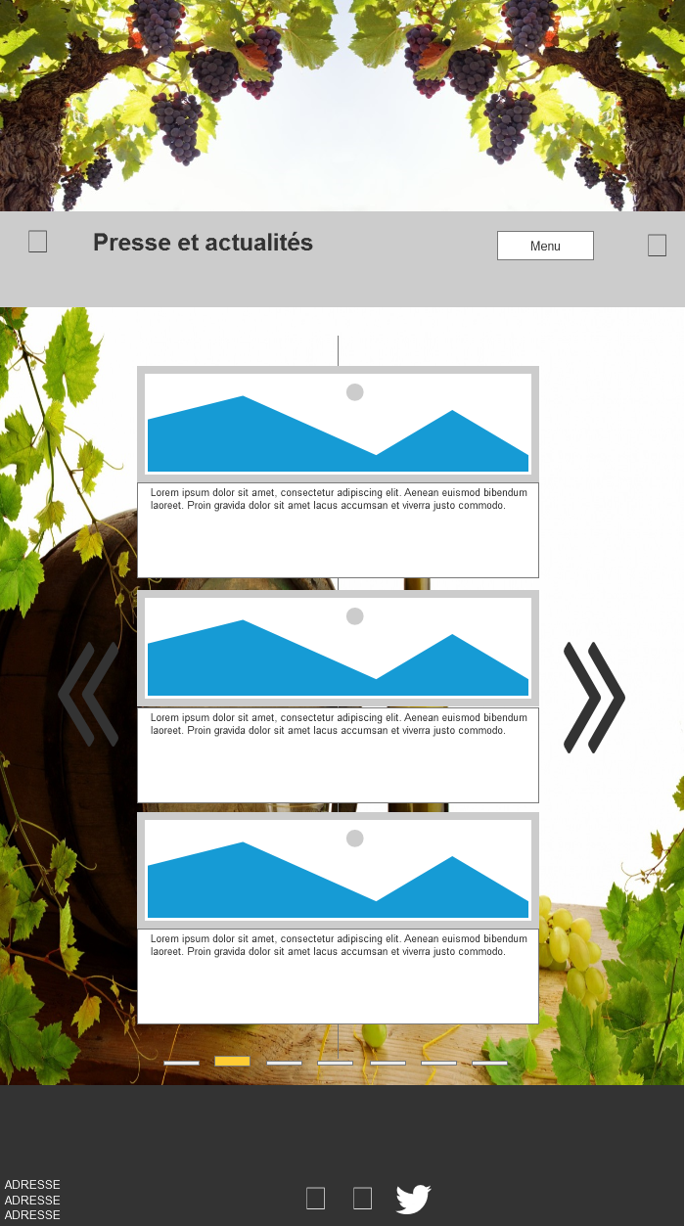

* 1. Commande
     1. User Interface

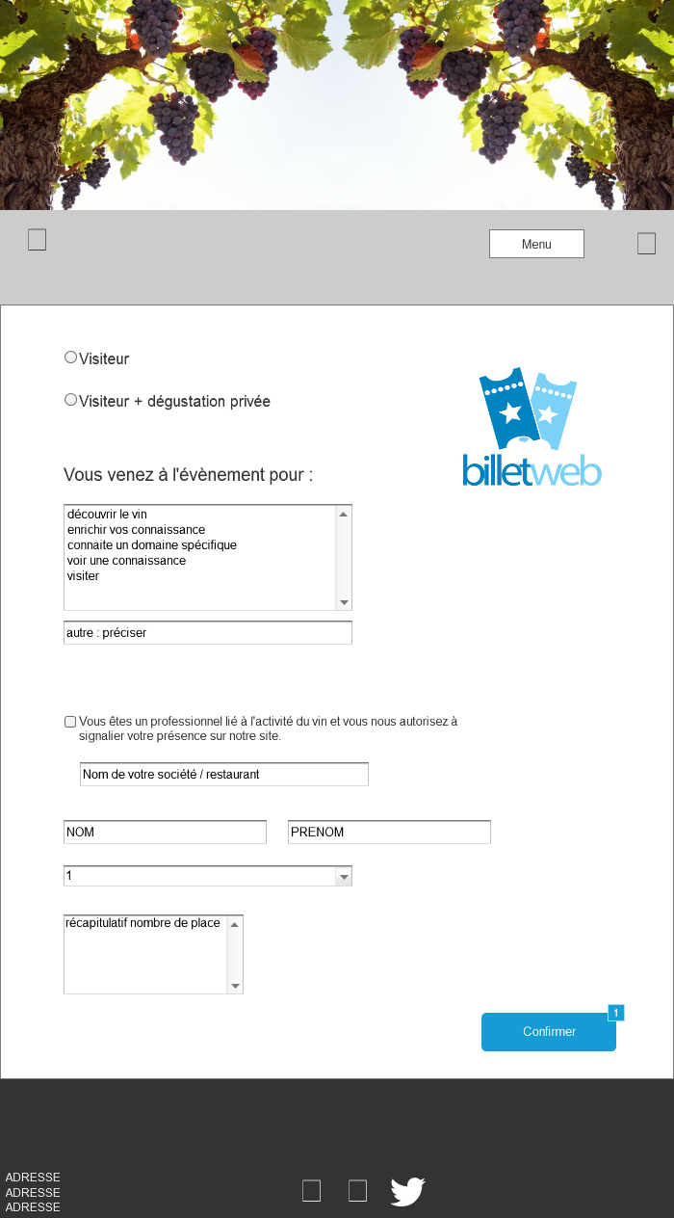

* + 1. Widget Table

| Footnote | Name | Interactions |
| --- | --- | --- |
| 1 |  | OnClick:  Case 1:  Open Confirmation in Current Window |

* 1. Confirmation
     1. User Interface

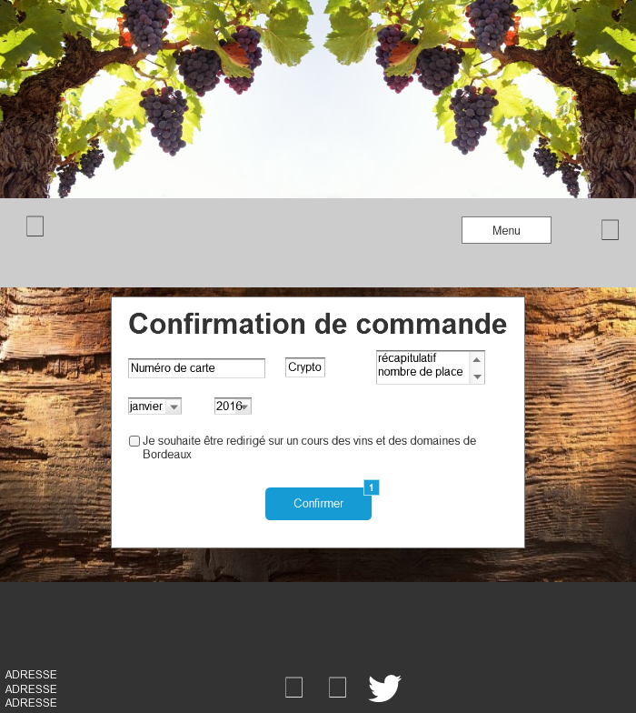

* + 1. Widget Table

| Footnote | Name | Interactions |
| --- | --- | --- |
| 1 |  | OnClick:  Case 1  (If is selected of checkbox cours equals true):  Open Connaissance sur le vin et le domaine in Current Window  Case 2  (Else If is selected of checkbox cours equals false):  Open Home Portable in Current Window |

* 1. Connaissance sur le vin et le domaine
     1. User Interface

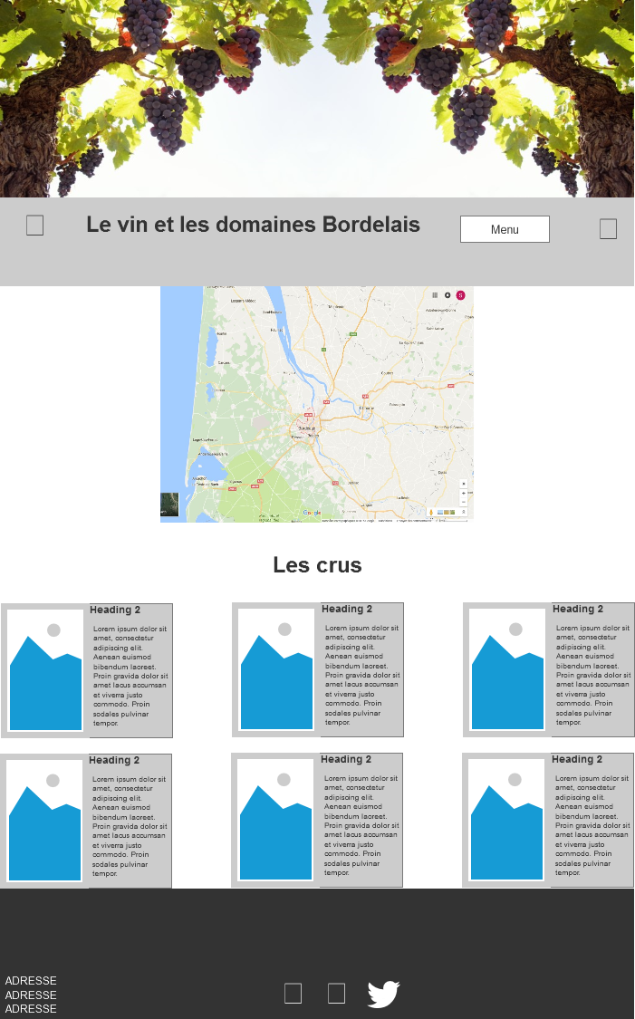

1. Masters
   1. Master List

header  
header portable  
header 2  
header 2 portable  
Contact  
Contact portable  
exposant  
exposant portable  
carte  
carte portable

* 1. header
     1. User Interface



* + 1. Widget Table

| Footnote | Name | Interactions |
| --- | --- | --- |
| 1 |  | OnClick:  Case 1:  Open Home in Current Window |
| 2 | Liste exposant | OnClick:  Case 1:  Open Liste des exposants in Current Window |
| 3 | intervenantTable | OnClick:  Case 1:  Open Intervenants à la table ronde in Current Window |
| 4 | PresseActualité | OnClick:  Case 1:  Open Presse et actualité in Current Window |
| 5 | commander | OnClick:  Case 1:  Open Commande in Current Window |
| 6 | Liste exposant | OnClick:  Case 1:  Open Carte des exposants in Current Window |
| 7 |  | OnClick:  Case 1:  Open Home in Current Window |

* 1. header portable
     1. User Interface



Menu Object

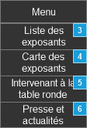

* + 1. Widget Table

| Footnote | Name | Interactions |
| --- | --- | --- |
| 1 |  | OnClick:  Case 1:  Open Home Portable in Current Window |
| 2 | commander | OnClick:  Case 1:  Open Commande in Current Window |
| 3 |  | OnClick:  Case 1:  Open Liste des exposants in Current Window |
| 4 |  | OnClick:  Case 1:  Open Carte des exposants in Current Window |
| 5 |  | OnClick:  Case 1:  Open Intervenant à la table ronde in Current Window |
| 6 |  | OnClick:  Case 1:  Open Presse et actualité in Current Window |

* 1. header 2
     1. User Interface

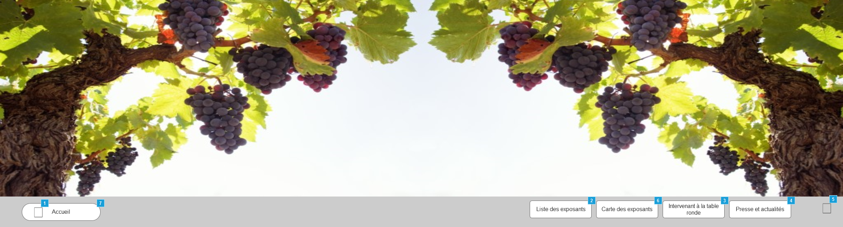

* + 1. Widget Table

| Footnote | Name | Interactions |
| --- | --- | --- |
| 1 |  | OnClick:  Case 1:  Open Home in Current Window |
| 2 | Liste exposant | OnClick:  Case 1:  Open Liste des exposants in Current Window |
| 3 | intervenantTable | OnClick:  Case 1:  Open Intervenants à la table ronde in Current Window |
| 4 | PresseActualité | OnClick:  Case 1:  Open Presse et actualité in Current Window |
| 5 | commander | OnClick:  Case 1:  Open Commande in Current Window |
| 6 | Liste exposant | OnClick:  Case 1:  Open Carte des exposants in Current Window |
| 7 |  | OnClick:  Case 1:  Open Home in Current Window |

* 1. header 2 portable
     1. User Interface

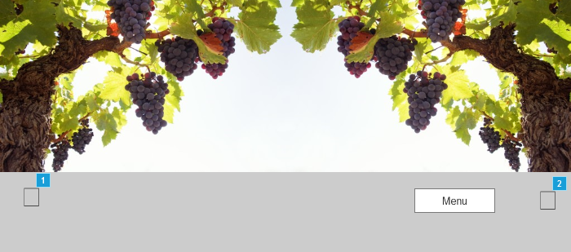

Menu portable

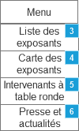

* + 1. Widget Table

| Footnote | Name | Interactions |
| --- | --- | --- |
| 1 |  | OnClick:  Case 1:  Open Home Portable in Current Window |
| 2 | commander | OnClick:  Case 1:  Open Commande in Current Window |
| 3 |  | OnClick:  Case 1:  Open Liste des exposants in Current Window |
| 4 |  | OnClick:  Case 1:  Open Carte des exposants in Current Window |
| 5 |  | OnClick:  Case 1:  Open Intervenant à la table ronde in Current Window |
| 6 |  | OnClick:  Case 1:  Open Presse et actualité in Current Window |

* 1. Contact
     1. User Interface



* 1. Contact portable
     1. User Interface



* 1. exposant
     1. User Interface

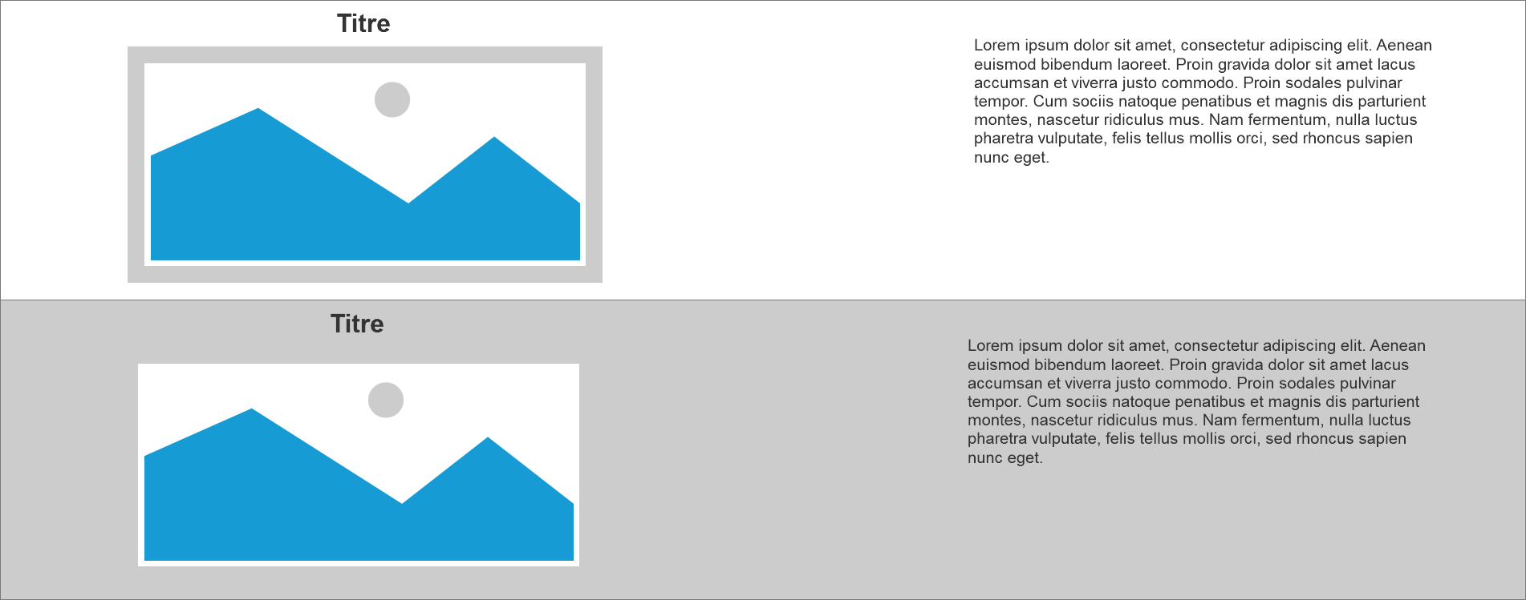

* 1. exposant portable
     1. User Interface

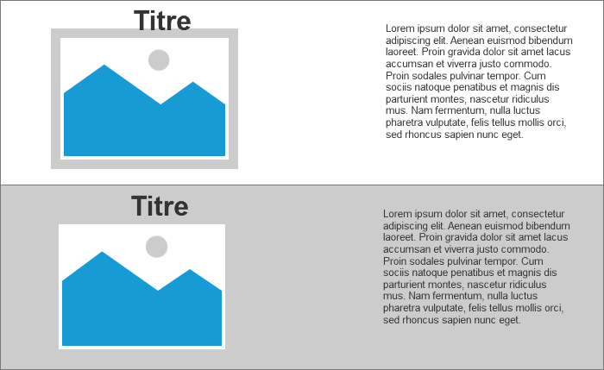

* 1. carte
     1. User Interface

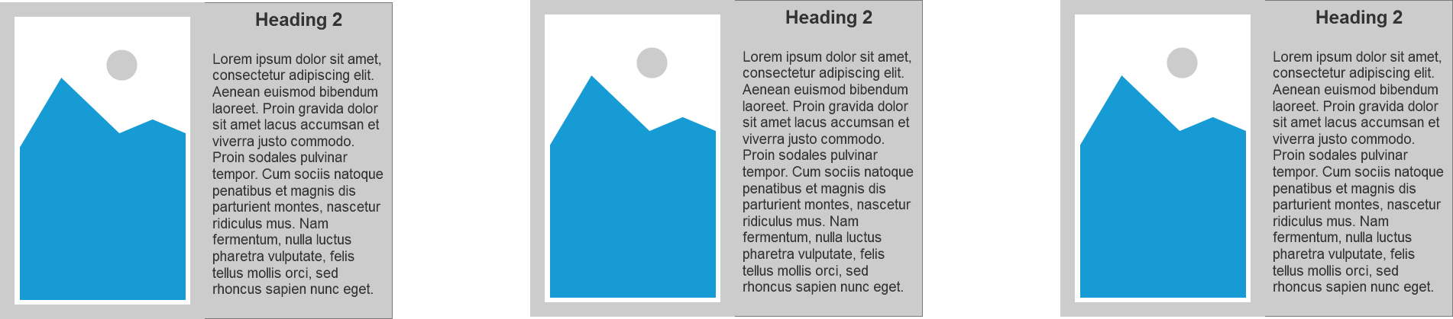

* 1. carte portable
     1. User Interface

